TECHNICAL REPORT
Automatic Water Tank Monitoring and Pump Control
No. | Name | Registration number
1 | Prince Mutezva | C24159614F

Technical Report: Automatic Water Tank Monitoring and Pump Control

1. Project overview
This project designs, builds and programs a system that keeps a water tank filled automatically: an ultrasonic sensor measures the water level, and a controller switches a 12 V pump on at 30% and off at 90%.
Problem and purpose
Manually watching a tank wastes time and risks two failures: running dry, which damages the pump, and overflowing, which wastes water. Automating the filling removes both, and shows the integration of mechanical, electrical and embedded design that the course assesses.
Objectives
- Design a watertight tank, lid, sensor mount, electronics enclosure and pump bracket in CAD.
- Manufacture the parts by 3D printing and assemble them.
- Measure the water level without touching the water, using an HC-SR04 ultrasonic sensor.
- Start the pump at 30% or below and stop it at 90% or above, with a gap between the two thresholds so the pump does not switch rapidly.
- Show the level and pump state on an LCD, with LEDs and a buzzer as indicators.
- Protect the pump and tank: if the sensor gives no echo, the pump is forced off.
- Build a working prototype with no breadboard, powered safely from a 12 V supply.
Design reasons
- Ultrasonic sensing: it does not touch the water, so it does not corrode or foul, and it gives a continuous level rather than a single point.
- Hysteresis (30% on, 90% off): one threshold would make the pump chatter around that level and wear the pump and driver; two thresholds give long, steady fill cycles.
- Driver stage: the controller's pins cannot supply the pump's current, and the pump produces voltage spikes when it stops, so a transistor and a relay separate them.
- Fault-safe default: a missing echo reads as zero distance, which would look like a full tank, so the code treats it as a sensor error and keeps the pump off.

2. System design and calculations
The prototype tank holds 12 L, the usable fill between the two thresholds is 7.2 L, and at an assumed pump flow of 1 L/min a fill takes about 7.2 minutes. assumed
Design values
Parameter | Value | Working
Internal tank size | 20 x 20 x 30 cm | Chosen to fit the printer and give a clear demonstration
Tank volume | 12 L | 20 x 20 x 30 = 12,000 cm3
Pump ON level | 30% (9 cm of water) | 0.30 x 30 cm
Pump OFF level | 90% (27 cm of water) | 0.90 x 30 cm
Usable fill volume | 7.2 L | 20 x 20 x (27 - 9) = 7,200 cm3
Pump flow (assumed) | 1 L/min | From the pump datasheet
Fill time | about 7.2 min | 7.2 L / 1 L/min
Safety timeout | about 11 min | 1.5 x fill time; the pump is forced off after this
Level from the sensor reading
The sensor sits in the lid and measures the distance d to the water surface. With H the distance from the sensor to the tank floor (30 cm), the level is:
\text{level}\,(\%) = \frac{H - d}{H} \times 100
The echo time t (in microseconds) gives the distance d = t x 0.0343 / 2 (in cm), where 0.0343 cm per microsecond is the speed of sound and the division by 2 allows for the out-and-back path.
Level | Water height | Sensor reading d
30% (pump ON) | 9 cm | 21 cm
90% (pump OFF) | 27 cm | 3 cm
The full mark leaves 3 cm between the sensor and the water, above the HC-SR04's minimum range of about 2 cm.
Electrical sizing
- Pump: a small 12 V pump draws about 0.5 A (6 W); check the datasheet. The relay contacts must be rated above this, and a small 5 V relay is typically rated several amps.
- Relay coil and driver: a typical 5 V relay coil draws 70 to 90 mA, more than an Arduino pin can supply (40 mA maximum). The 2N2222 switches it, and the 1 k base resistor sets a base current of (5 - 0.7) / 1000 = about 4.3 mA, so the pin stays well within its limit.
- Supply: pump 0.5 A plus the Uno, relay coil, LCD and LEDs under 0.7 A gives about 1.2 A, so a 12 V, 2 A adapter has margin.
- Arduino supply: the Uno's barrel jack accepts 7 to 12 V, but its regulator runs hot at 12 V, so a buck converter (LM2596, rated 3 A) steps the 12 V down to about 9 V for the jack.
- Sensor level: the HC-SR04 runs at 5 V, the same as the Uno's logic, so no level shifting is needed.
- Indicator LEDs: a 220 ohm resistor from 5 V with a 2 V LED passes (5 - 2) / 220 = about 14 mA.

3. Mechanical design (CAD)
The mechanical system is six parts modelled in SolidWorks (millimetres), assembled around a one-piece 3D-printed tank that has no seams to leak. The figures below show the modelled parts and then the finished assembly.
Parts
Part | Main features | Key dimensions
Tank | One-piece open box, filleted corners, shelled inward | 206 x 206 x 303 mm outside; 200 x 200 x 300 mm inside; 3 mm walls and floor
Lid | Plate with a locating rim underneath, sensor pocket, cable slot, inlet hole | 210 x 210 x 3 mm; rim 199.4 mm square, 2 mm wall, 5 mm tall (0.3 mm clearance per side); inlet hole 10.5 mm; cable slot 10 x 4 mm
Sensor pocket | Frame on the lid that holds the HC-SR04 | Two 17 mm holes, 26 mm centres; frame 52 x 26 mm outside, 47 x 21 mm inside, 6 mm tall
Hose adapter | Flange with a neck and a through-bore | 20 mm flange, 3 mm thick; 10 mm neck, 20 mm long; 6 mm bore
Electronics enclosure | Shelled box with corner posts and cutouts | 125 x 85 x 45 mm outside; 2.5 mm walls; 4 mm post holes for M3 inserts
Cover | Plate fixed to the enclosure posts | 125 x 85 x 2.5 mm; four 3.4 mm holes
Pump bracket | Base plate with a U-shaped cradle and zip-tie slot | Cradle width = pump width + 0.5 mm; two 3.4 mm screw holes
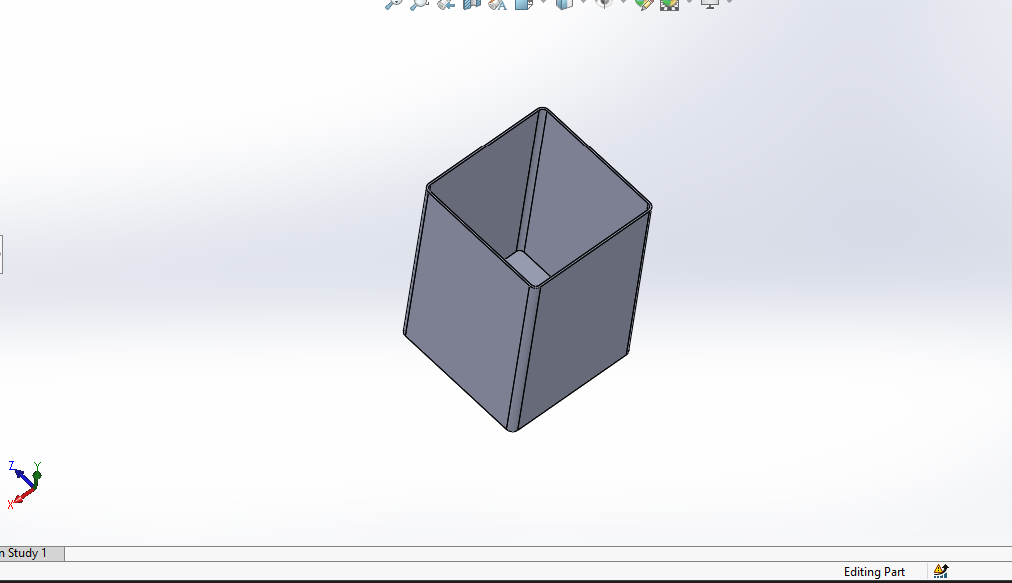
Figure 1: Tank, a one-piece open box shelled inward.
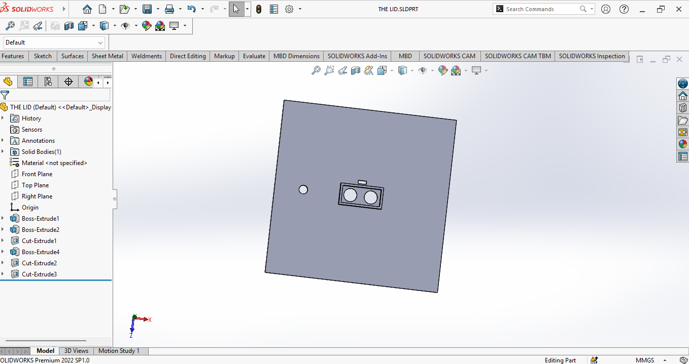
Figure 2: Lid with locating rim, sensor pocket with two holes, cable slot and inlet hole.
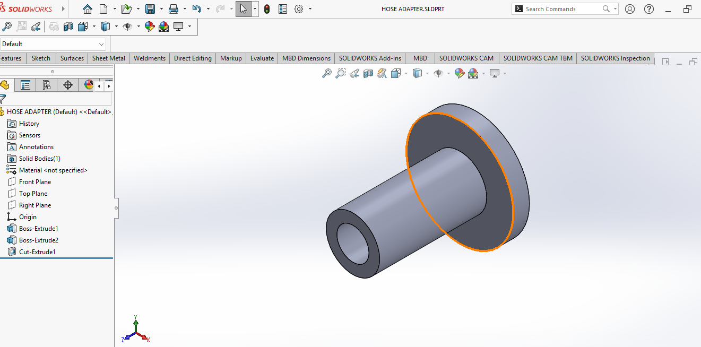
Figure 3: Hose adapter, a flange with a 10 mm neck and a 6 mm through-bore.
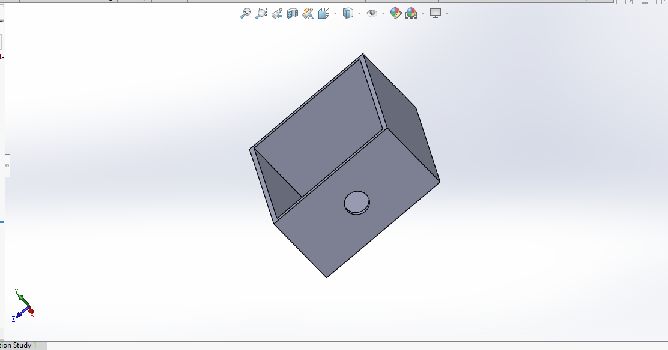
Figure 4: Electronics enclosure with a cutout in the wall.
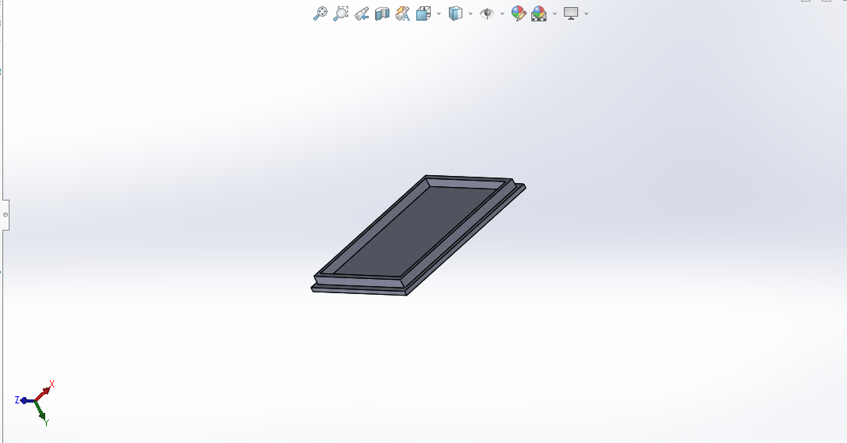
Figure 5: Cover with a raised rim.
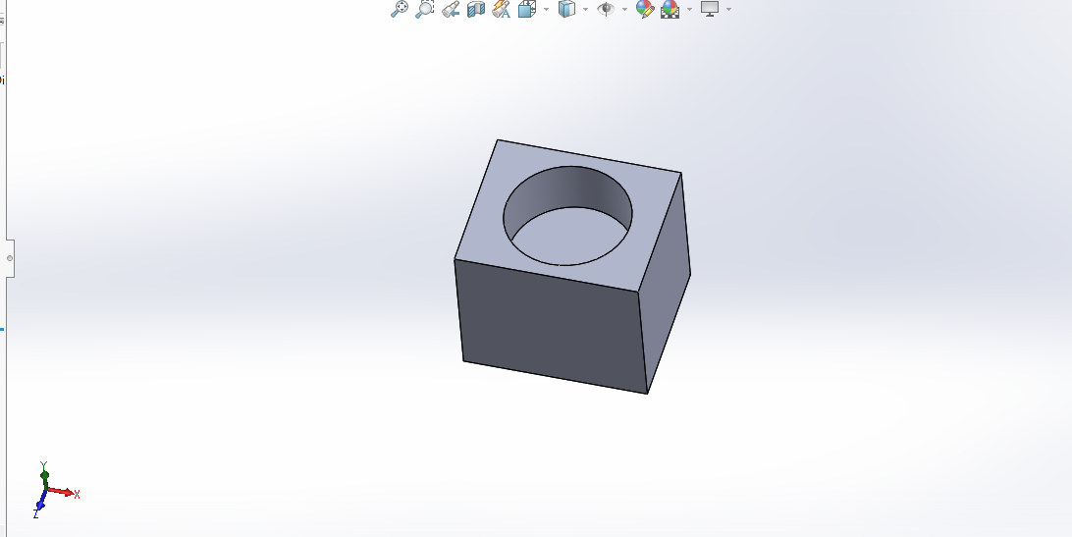
Figure 6: Pump bracket block with a round recess.
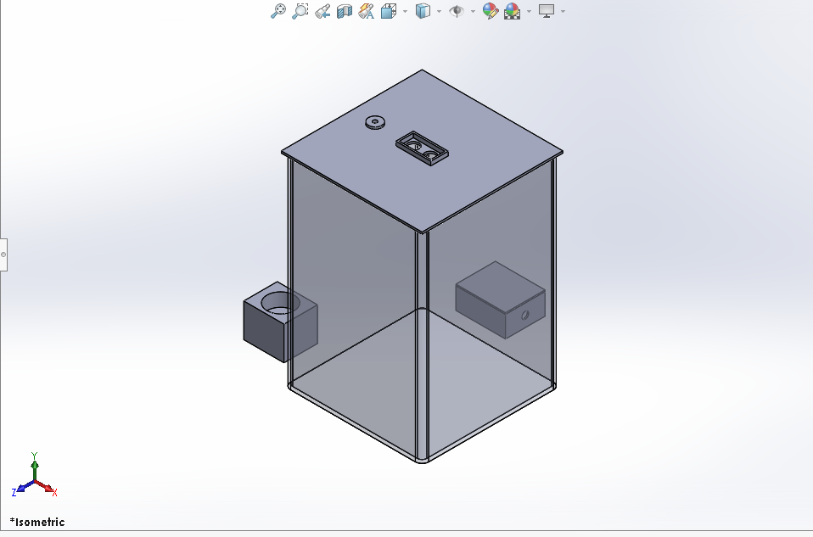
Figure 7: Assembly, isometric view with the tank shown transparent: the lid carries the sensor frame and hose adapter, the pump bracket stands on the left, and the enclosure with its cover stands beside the tank.
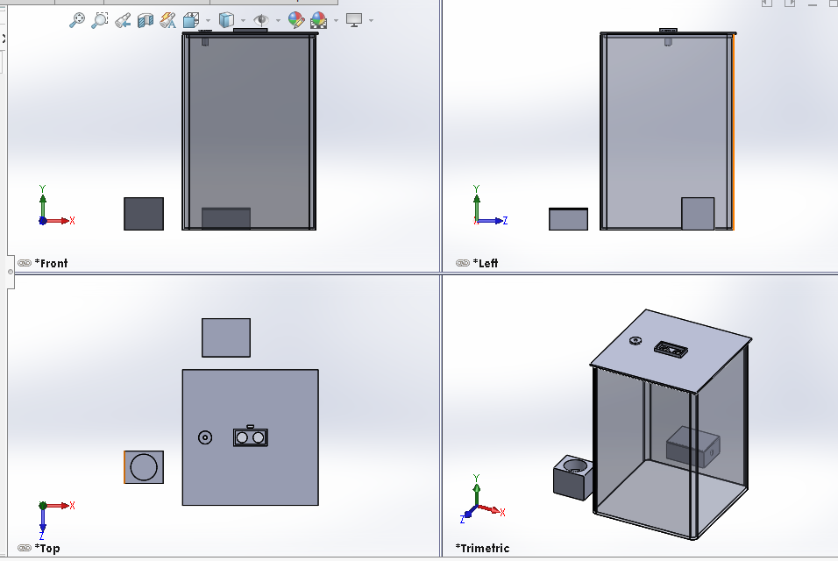
Figure 8: Assembly in front, left, top and trimetric views.
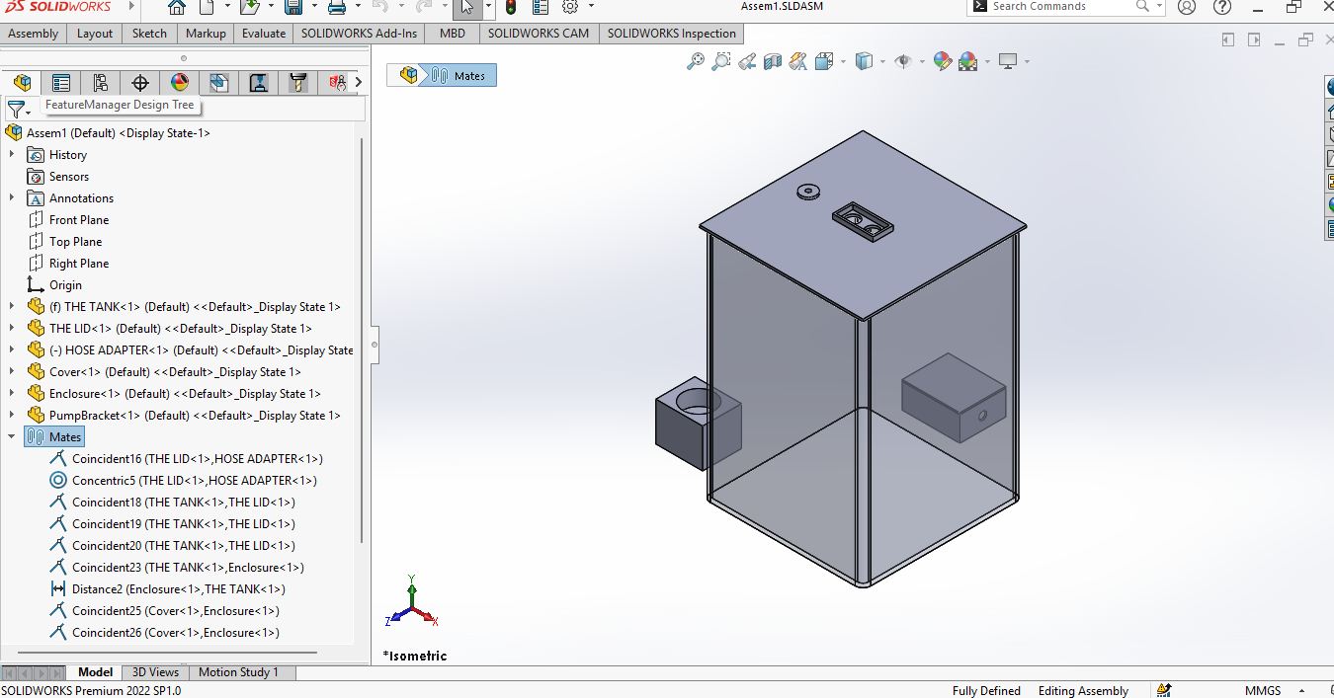
Figure 9: The SolidWorks Mates folder. The status bar reads "Fully Defined", so no mate is over- or under-defined.
Design reasons
- One-piece tank: every joint is a place for water to escape, so the tank is a single print with filleted corners that are stronger and easier to seal.
- Lid rim: it centres the lid on the tank opening and stops it sliding, with 0.3 mm clearance so it fits after printing.
- Sensor holes and pocket: the sensor faces straight down through the lid, and the pocket stops the board from moving.
- Separate enclosure: the electronics sit beside the tank and above the water line, away from any spill.
Assembly
The tank is fixed at the origin. The lid sits on the tank rim and is centred with Coincident mates on its underside and two side faces. The hose adapter is concentric with the inlet hole, with its flange against the underside of the lid, so the neck hangs down into the tank. The enclosure stands on the same floor level as the tank, 20 mm from its wall, with the cover mated on top of it. The pump bracket stands on the same floor level, 30 mm from the tank wall. The mates leave the assembly fully defined (Figure 9).

4. Electrical design
Only the pump runs at 12 V, on its own supply behind the relay contacts; the Arduino Uno, sensor, LCD, LEDs and relay coil run at 5 V, so no component sees more voltage than it is rated for. The Proteus schematic is shown below; we will add a photo of the soldered board once it is built.
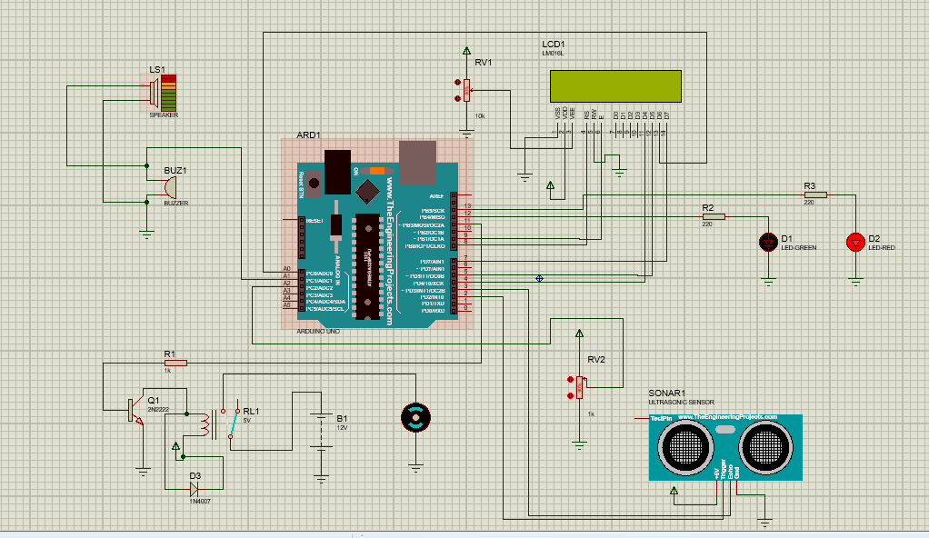
Figure 10: Circuit schematic in Proteus, with the simulation-only sensor pot (RV2) and speaker (LS1).
Components
Part (Proteus label) | Role | Supply
Arduino Uno (ARD1) | Controller | 5 V logic; 7 to 12 V on the barrel jack, or USB
HC-SR04 (SONAR1) | Measures the distance to the water | 5 V
5 V SPDT relay (RL1) | Switches the pump's 12 V supply | 5 V coil
2N2222 (Q1) and 1 k resistor (R1) | Drive the relay coil from a pin | 5 V
1N4007 diode (D3) | Absorbs the spike when the relay coil switches off | n/a
12 V DC pump (motor) and 12 V supply (B1) | Moves the water | 12 V, through the relay contacts
16x2 LCD (LCD1) and 10 k contrast pot (RV1) | Shows the level and pump state | 5 V
Green LED (D1), red LED (D2), 220 ohm resistors (R2, R3) | Pump running, pump off | 5 V
Buzzer (BUZ1) | Tank full | 5 V
1 k pot (RV2) on the sensor's TestPin | Simulation only: sets the simulated distance | n/a
Speaker (LS1) | Simulation only: plays the buzzer sound in Proteus | n/a
Pin assignment (Arduino Uno)
Function | Uno pin
HC-SR04 Trig / Echo | D2 / D3
LCD RS / E | D8 / D9
LCD D4 / D5 / D6 / D7 | D4 / D5 / A0 / D7
Relay driver (through 1 k to the 2N2222 base) | D11
Green LED | D12
Red LED | D13
Buzzer | A1
Protection against over-voltage and damage
- The pump runs on its own 12 V supply and is connected only through the relay contacts, so the 12 V never reaches the Uno's pins. The relay coil runs from the 5 V rail.
- Never connect 12 V to the Uno's 5V pin or to any I/O pin. The barrel jack takes 7 to 12 V, and a buck converter set to about 9 V keeps the regulator cool. Measure the converter's output with a multimeter before plugging in the Uno.
- D3 (1N4007) sits across the relay coil to absorb the spike when it switches off. Add a second 1N4007 across the pump terminals, with the stripe toward the positive wire, for the pump's own spike.
- R1 (1 k) limits the base current of the 2N2222 to about 4.3 mA, so pin D11 is never overloaded.
- The 220 ohm resistors limit each LED to about 14 mA.
- A 1 to 2 A fuse, a reverse-polarity diode and a 470 to 1000 uF capacitor sit on the 12 V supply, close to the relay and pump.
- The buzzer is driven through a 2N2222 transistor with a 1 k base resistor, or replaced by an active buzzer module. In Proteus the buzzer model is a 12 ohm load, which would draw about 400 mA and overload a pin.
- The grounds of the Uno, sensor, LCD, relay coil supply and transistor emitter are joined. The pump supply stays separate, switched only by the relay.
- The circuit is soldered on perfboard with terminal blocks (no breadboard), and the enclosure is kept above the water line.

5. Embedded software
The program reads the sensor once a second, turns the distance into a level percentage, and sets the pump with two thresholds (ON at 30% or below, OFF at 90% or above) so it keeps its previous state in between.
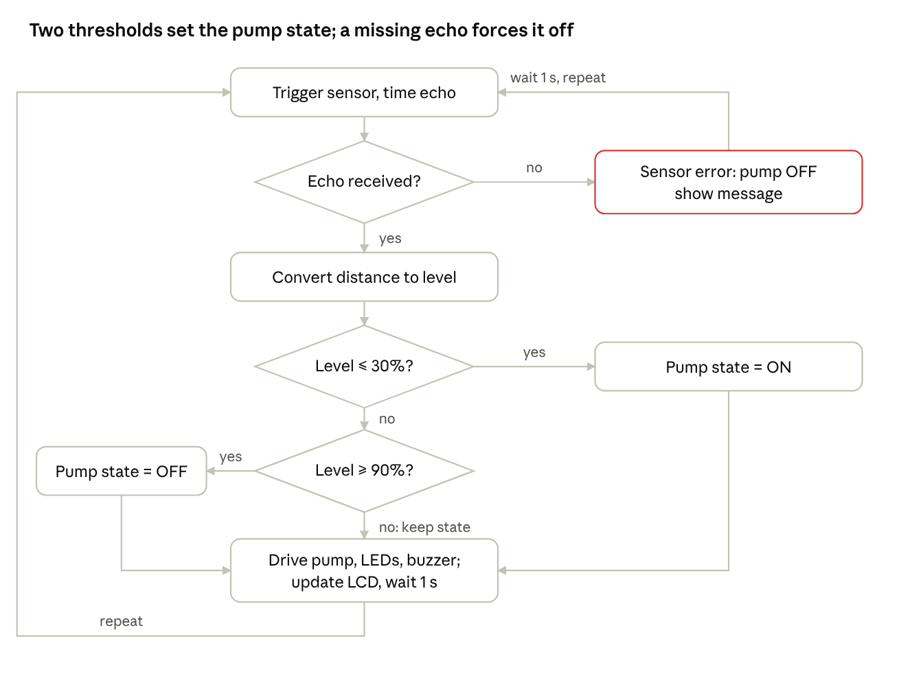
control loop · 3 decisions, 1 fault path
A missing echo is checked first: it forces the pump off and shows an error, instead of being read as a full tank.
How the code works
- Measure: the code sends a 10 microsecond pulse on the trigger pin and times the echo with a 30 ms timeout.
- Check for a fault: a timeout returns 0, which would give a distance of 0 cm and a level of 100%. The code tests for this first, switches the pump off and shows "Sensor error".
- Convert: the distance becomes a level percentage, limited to 0 to 100.
- Decide with hysteresis: a stored variable holds the pump state. It becomes ON at 30% or below and OFF at 90% or above, and otherwise keeps its value. Without this memory the pump turned off as soon as the level passed 30% and never filled the tank.
- Act: the pump driver, the green LED (pump running), the red LED (pump off) and the buzzer (tank full) are set from the pump state and the full flag, and the LCD shows the level and status.
- Wait: a one second delay sets the reading rate and keeps the display steady.
- Real build only: a maximum pump run time of about 11 minutes puts the system into a fault state if the level never reaches the full mark, which would indicate a dry source or a blocked hose.
The complete code is in the appendix.

6. Testing and results
In Proteus the pump rule, the LCD, the LEDs and the sensor-fault protection all behaved as designed; the buzzer's sound could not be confirmed because the simulator ran slower than real time. The physical tests below are still to be done on the prototype.
Proteus simulation results
Test | Result
Level 8% | LCD "Water: 8%, Pump: ON", green LED on, red LED off
Level 50% while filling | Pump stays ON (hysteresis)
Level 90% | LCD "Tank FULL", red LED on, green LED off, pump off, buzzer pin high
No echo from the sensor | LCD "Sensor error", pump off
Level 50% while draining | LCD "Water: 50%, Pump: OFF", red LED on, green LED off: the pump stays OFF at the same level where it was ON while filling
Screenshots of the simulated states follow.
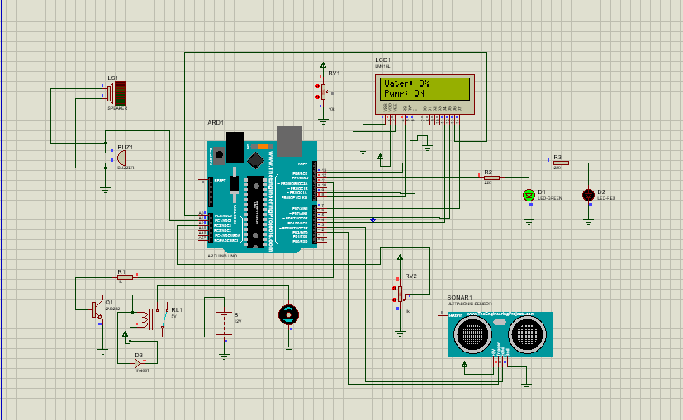
Figure 11: Level 8%, pump ON, green LED lit.
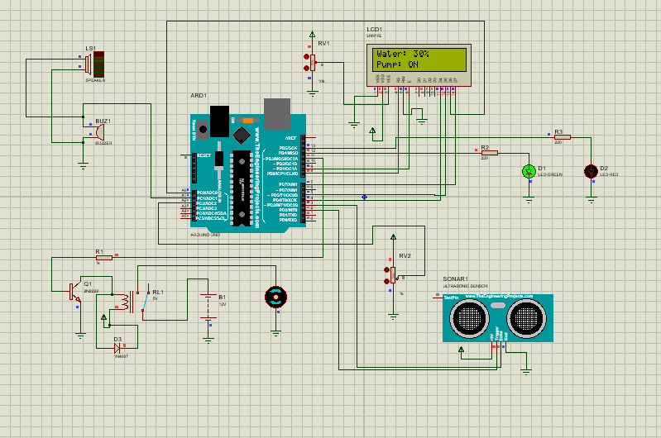
Figure 12: Level 30%, pump ON, green LED lit (the switch-on threshold).
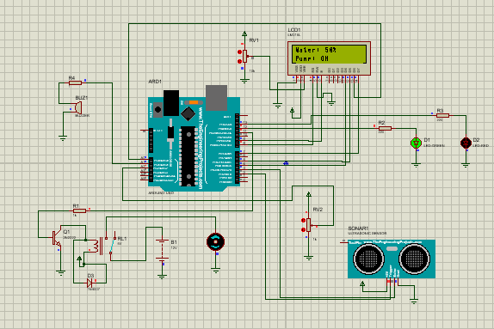
Figure 13: Level 50% while filling, pump still ON.
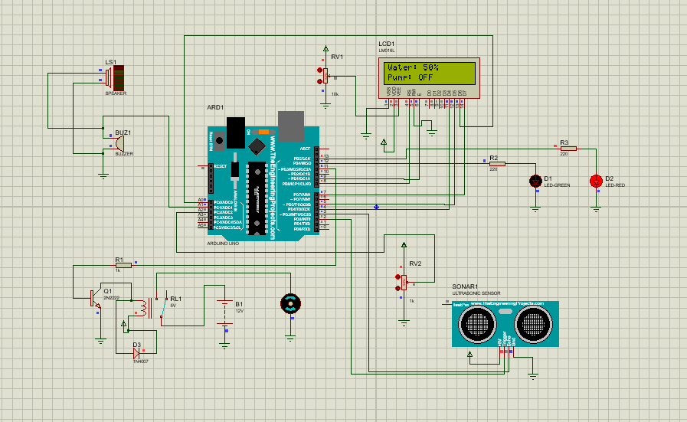
Figure 14: Level 50% while draining, pump OFF, red LED lit. The same level as Figure 13 with the opposite pump state shows the hysteresis.
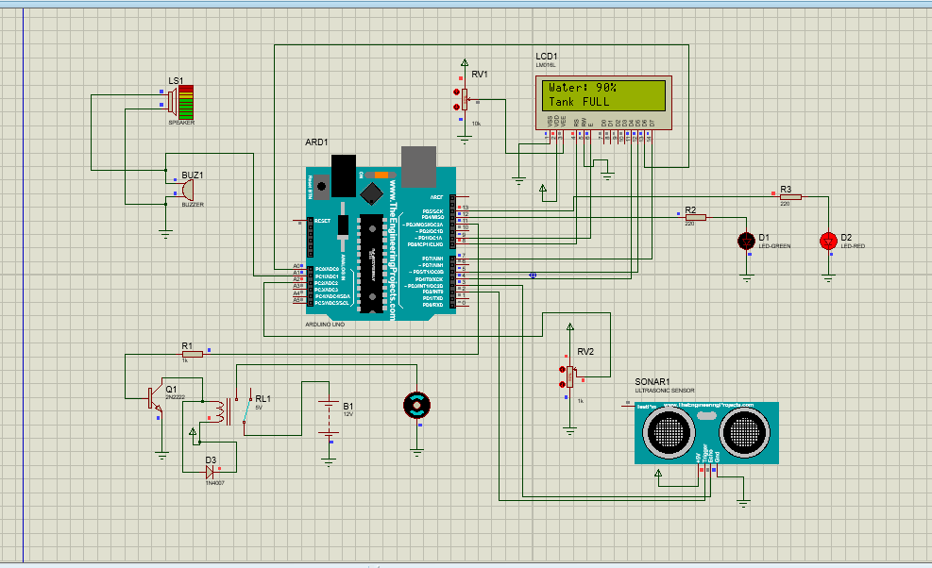
Figure 15: Level 90%, "Tank FULL", red LED lit, pump off.
Issues found and fixed in simulation
- The first code turned the pump off between 30% and 90%, so it never filled the tank. Storing the pump state fixed it.
- A missing echo read as 0 cm, which looked like a full tank. It is now treated as a sensor error.
- The Proteus ultrasonic model overloaded the simulator, giving CPU-load warnings. For the demo a potentiometer on an analog pin stood in for the sensor; the real build uses the HC-SR04.
- A 100 ohm resistor in series with the simulated 12 ohm buzzer left it about 0.5 V, too little to sound. In the real build the buzzer is driven through a transistor.
Prototype tests (to complete)
Test | Expected result | Result
Tank leak test: filled to the top for several hours | No water seen outside the tank | Not tested
Buck converter output measured before connecting the Uno | About 9 V (within a few percent) | Not tested
Empty tank | Pump ON, green LED on | Not tested
Filling between 30% and 90% | Pump stays ON | Not tested
Level reaches 90% | Pump OFF, red LED and buzzer on, "Tank FULL" shown | Not tested
Level draining from full to 30% | Pump stays OFF until 30%, then turns ON | Not tested
Sensor disconnected | "Sensor error", pump OFF | Not tested
Power loss and restart | System restarts safely with the pump off until a valid reading | Not tested
Measured fill time against the 7.2 min estimate | Within the 11 min safety timeout | Not tested

7. Manufacturing and assembly
This section describes how the six CAD parts become the working prototype. We will 3D print the parts, check how they fit, make the tank watertight, and then assemble the mechanics and the electronics. The plan is set out below; update the status columns as each step is done and add the photos at the end.
What we will do
Stage | What we will do | Evidence to include
1. Printing | Print the tank, lid, hose adapter, enclosure, cover and pump bracket in PLA | Print settings table, a photo of each part
2. Fit check | Test the sensor pocket first, then check the lid rim, post holes, hose adapter and pump cradle | Fit check table, a note of every change made
3. Sealing and leak test | Seal the tank and the adapter joint, fill the tank and leave it for several hours | Leak test table, a photo of the sealed tank
4. Mechanical assembly | Fit the lid, sensor, hose adapter, pump bracket and enclosure | A photo of the finished mechanical assembly
5. Electronics assembly | Solder the circuit on perfboard (no breadboard), mount it in the enclosure and route the cables | Photos of the board and the wired enclosure, the buck converter voltage reading
7.1 Printing
The tank is printed upright as one piece with solid walls, so water cannot pass between layers. The sensor pocket is printed first as a small test piece. The settings below are the plan: change them to what was actually used, and add the printer model, the filament and the print time from the slicer.
Part | Material | Layer height | Walls | Infill | Status
Tank | PLA | 0.2 mm | 4 | Solid base | Not printed
Lid | PLA | 0.2 mm | 3 | 20% | Not printed
Hose adapter | PLA | 0.16 mm | 4 | 100% | Not printed
Electronics enclosure | PLA | 0.2 mm | 3 | 20% | Not printed
Cover | PLA | 0.2 mm | 3 | 20% | Not printed
Pump bracket | PLA | 0.2 mm | 4 | 40% | Not printed
7.2 Fit check
Each check passes when the real part fits without force. Record every change in the log under 7.7.
Check | Passes when | Result
HC-SR04 in the sensor pocket | Both sensors sit in the 17 mm holes and the board does not slide | Not checked
Lid on the tank | The rim enters the tank freely and the lid sits flat | Not checked
Hose adapter in the lid | The neck passes through the inlet hole and the flange sits against the lid | Not checked
Inserts in the enclosure posts | The M3 heat-set inserts seat in the 4 mm holes | Not checked
Cover on the enclosure | All four screw holes line up with the posts | Not checked
Pump in its bracket | The pump sits in the cradle and the screw holes line up | Not checked
7.3 Sealing and leak test
- Seal the inside corners of the tank and the hose adapter joint with waterproof silicone or epoxy, and let it cure.
- Fill the tank to the top and leave it for several hours, checking the outside and the base for moisture.
- Only after it passes, mount the sensor and bring the electronics near.
Test | Method | Result
Tank leak test | Fill to the top, leave for several hours, note the start time and duration | Not tested
Hose adapter joint | Pour water through the bore and check the seal | Not tested
Pump and tubing | Run the pump with water and check each tubing joint | Not tested
7.4 Mechanical assembly
- Push the hose adapter's neck up through the inlet hole from underneath, so the flange sits against the underside of the lid, and seal it.
- Place the HC-SR04 in the pocket with its two sensors through the holes, and secure it.
- Lower the lid onto the tank.
- Screw the pump into its bracket, and connect the tubing from the pump to the adapter's neck.
- Place the enclosure beside the tank, above the water level.
7.5 Electronics assembly
- Solder the circuit onto perfboard, using header sockets for the Arduino Uno and terminal blocks for the pump and supply.
- Set the buck converter to about 9 V and check it with a multimeter before connecting the Uno.
- Fit the board in the enclosure on the M3 heat-set inserts, and route the cables through the slot.
- Connect the pump through the relay contacts, then the sensor, LCD and indicators.
- Fit the cover and test each stage alone before testing them together.
7.6 Tools and materials
3D printer and PLA filament, soldering iron, multimeter, vernier caliper, screwdrivers, silicone gun and sealant, M3 heat-set inserts and screws, zip ties.
7.7 Fit problems log
Record each part that needed a reprint, sanding or a changed dimension, and what was changed.
Part | Problem | Change made

8. Conclusion and improvements
The design and the Proteus simulation show that two thresholds (ON at 30%, OFF at 90%) fill the tank without the pump switching rapidly, and that a missing sensor echo forces the pump off. Update this paragraph with the measured results once the prototype tests in section 6 are done, including the measured fill time against the 7.2 minute estimate.
Possible improvements
- Add a float switch at the full mark as an independent overflow cut-off in case the ultrasonic sensor fails.
- Add a low-level sensor in the supply container to detect a dry source directly instead of relying on the run-time limit.
- Move to an ESP32, or add a Bluetooth module, to report the level and pump state to a phone.
- Add a flow sensor to measure the actual pump flow and detect a blocked hose.
- Filter the readings (the median of five) to reduce noise from ripples and splashing.

Appendix: bill of materials and code
Bill of materials
Part | Qty | Notes
Arduino Uno | 1 | Controller
HC-SR04 ultrasonic sensor | 1 | Level sensing, 5 V
5 V SPDT relay | 1 | Contacts rated above the pump current
2N2222 transistor | 1 | Relay driver
1N4007 diodes | 2 | One across the relay coil, one across the pump
12 V DC water pump | 1 | Rated current under 0.5 A
12 V, 2 A adapter and DC barrel jack | 1 | Pump supply and Uno supply
LM2596 buck converter | 1 | 12 V down to about 9 V for the Uno
Fuse (1 to 2 A) and holder | 1 | On the 12 V line
Diode (1N5819 or 1N4007) | 1 | Reverse-polarity protection
Electrolytic capacitor, 470 to 1000 uF | 1 | Across the 12 V supply
Resistors 1 k | 2 | Relay driver and buzzer driver bases
Resistors 220 ohm | 2 | LED current limiting
2N2222 transistor | 1 | Buzzer driver
16x2 LCD and 10 k pot | 1 | Level and status display, contrast control
Green and red LEDs | 2 | Pump running and pump off
Buzzer | 1 | Tank full
On/off switch | 1 | Main power
Perfboard, headers, terminal blocks | 1 set | No breadboard
M3 heat-set inserts and screws | 1 set | Enclosure and bracket
PLA filament | about 1 kg | Check your slicer's estimate
Silicone sealant or epoxy | 1 | Seals the tank and adapter
Silicone tubing | as needed | Matches the adapter neck
Control code (Arduino Uno pins, as simulated in Proteus)
The pins match the table in section 4. Set TANK_HEIGHT to the distance from the sensor to the tank floor in cm (30 for the real tank; 400 was used in Proteus to match the simulator's sensor model).
#include <LiquidCrystal.h>
// HC-SR04
const int TRIG_PIN = 2;
const int ECHO_PIN = 3;
// LCD: RS, E, D4, D5, D6, D7
LiquidCrystal lcd(8, 9, 4, 5, A0, 7);
// Outputs
const int RELAY_PIN = 11;
const int GREEN_LED = 12;
const int RED_LED = 13;
const int BUZZER = A1;
// Tank settings (distance from sensor to tank floor, in cm)
const float TANK_HEIGHT = 30.0;
const int LOW_LEVEL = 30; // pump ON at or below this %
const int FULL_LEVEL = 90; // pump OFF at or above this %
bool pumpOn = false;
void setup() {
pinMode(TRIG_PIN, OUTPUT);
pinMode(ECHO_PIN, INPUT);
pinMode(RELAY_PIN, OUTPUT);
pinMode(GREEN_LED, OUTPUT);
pinMode(RED_LED, OUTPUT);
pinMode(BUZZER, OUTPUT);
digitalWrite(RELAY_PIN, LOW);
digitalWrite(GREEN_LED, LOW);
digitalWrite(RED_LED, HIGH);
digitalWrite(BUZZER, LOW);
lcd.begin(16, 2);
lcd.clear();
lcd.print("Water Level");
delay(1000);
lcd.clear();
}
void loop() {
// Send ultrasonic pulse
digitalWrite(TRIG_PIN, LOW);
delayMicroseconds(2);
digitalWrite(TRIG_PIN, HIGH);
delayMicroseconds(10);
digitalWrite(TRIG_PIN, LOW);
// Measure echo (timeout 30 ms)
long duration = pulseIn(ECHO_PIN, HIGH, 30000);
// Sensor error: no echo received -> pump off for safety
if (duration == 0) {
pumpOn = false;
digitalWrite(RELAY_PIN, LOW);
digitalWrite(GREEN_LED, LOW);
digitalWrite(RED_LED, HIGH);
digitalWrite(BUZZER, LOW);
lcd.setCursor(0, 0);
lcd.print("Sensor error ");
lcd.setCursor(0, 1);
lcd.print("Pump: OFF ");
delay(1000);
return;
}
// Distance in cm
float distance = duration * 0.0343 / 2;
// Water level percentage
float waterLevel = ((TANK_HEIGHT - distance) / TANK_HEIGHT) * 100;
if (waterLevel < 0) waterLevel = 0;
if (waterLevel > 100) waterLevel = 100;
// Pump logic with hysteresis
if (waterLevel <= LOW_LEVEL) pumpOn = true;
if (waterLevel >= FULL_LEVEL) pumpOn = false;
bool tankFull = (waterLevel >= FULL_LEVEL);
// Outputs
digitalWrite(RELAY_PIN, pumpOn);
digitalWrite(GREEN_LED, pumpOn);
digitalWrite(RED_LED, !pumpOn);
digitalWrite(BUZZER, tankFull);
// LCD (overwrite instead of clearing, avoids flicker)
lcd.setCursor(0, 0);
lcd.print("Water: ");
lcd.print((int)waterLevel);
lcd.print("% ");
lcd.setCursor(0, 1);
if (tankFull) lcd.print("Tank FULL ");
else if (pumpOn) lcd.print("Pump: ON ");
else lcd.print("Pump: OFF ");
delay(1000);
}

